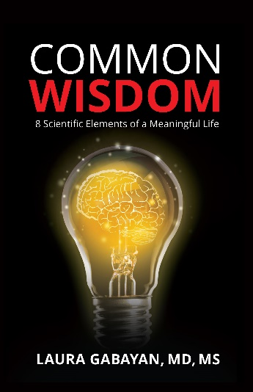
COMMON WISDOM SYNOPSIS

Common Wisdom is a fascinating and enlightening exploration describing the eight scientifically derived elements of wisdom that will profoundly change lives. The author, Dr. Laura Gabayan, is a world-renowned physician-researcher who extensively interviewed 60 wise individuals who responded to a series of questions about their thoughts on wisdom and their lives. Their responses were meticulously reviewed, and utilizing actual scientific methodology, arrived at eight common elements shared among these fascinating individuals. Common Wisdom discusses these elements at length, incorporating interesting facts and questions into the discussion, and also includes relatable stories from the interviewees, making this a book that is not only difficult to put down the first time reading it, but also a book that will have you picking it up again and again to discover even more meaning with each reading.
Common Wisdom answers two questions: What is wisdom? Can it be scientifically defined? Using the six steps of the scientific method, the research presented in the book determined that it is possible to define wisdom scientifically. The methodology is straight-forward, but interpreting the data required nuanced and complex thought. And what is wisdom? Arriving at that answer is the journey Common Wisdom takes the reader on. The goal of the book is to lead readers closer to defining what wisdom is for themselves. The eight elements of wisdom discussed help find balance in our lives, enriching it in surprising and powerful ways, giving it greater meaning and purpose. How we get there is through embodying these eight elements with sincerity and honesty.
Knowing the eight elements of wisdom is fantastic, but not enough. Using them and integrating them into our daily lives is where the magic happens. That may sound simple, but, according to our participants, it’s not always easy. It’s a process. Common Wisdom shows how to apply that knowledge, think about those facts and concepts, and apply them to our lives in order to transform knowledge into wisdom. It also shows that working to understand how each of these eight elements are interrelated will lead to profound and life-changing insight and inspiration. People don’t live in a vacuum, and neither do these elements; they are dynamic, evolving, and interconnected. By working to see their interconnectedness, we become closer to wisdom.
Common Wisdom will give the reader compelling food for thought on identifying ways to improving our understanding and abilities relating to these eight elements, leading to a wiser and more meaningful life.

