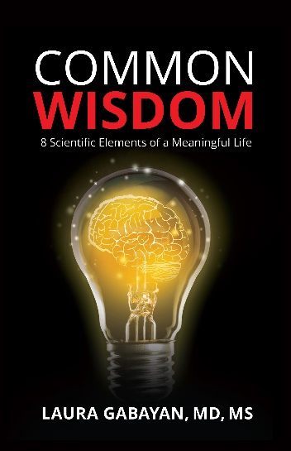

SAMPLE QUESTIONS FOR
COMMON WISDOM: 8 Scientific Elements of a Meaningful Life

- Why did you decide to study wisdom? How did the idea for this research come about?

- Your research led you to the discovery of eight primary elements of wisdom? Which of the elements surprised you the most? Why?

- Which element was most difficult to describe or put into context? Why?

- How did your views change regarding these elements from before doing this research and after?

- You state that people reading this book should revisit the book often. Why is that?

- Following your research, do you believe that the purpose of life is to attain wisdom, or do we use wisdom for the purpose of attempting to understand the meaning of life? Or both? Why?

- You discuss the interconnectedness of these elements. Why is it important for readers to understand how each of these elements are interconnected?

- Do you think each person reading this will discover their own definition of wisdom? Why?

- What do you hope readers will take away from this book?

- Where can people purchase Common Wisdom?

