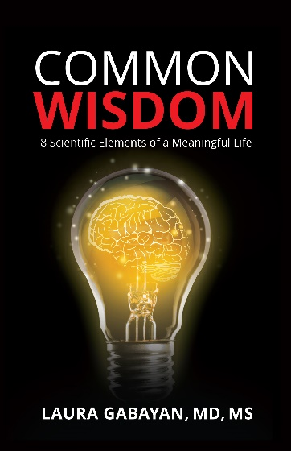

Dr. Laura Gabayan Biography

Dr. Laura Gabayan is a world-renowned physician and researcher. Regarded internationally as an expert in the field of emergency medicine, she has received multiple research grants and awards for her work. She has also published dozens of papers cited by hundreds of researchers. She attended UCLA for her schooling and is now affiliated with the UCLA School of Medicine.

The only daughter of Kurdish immigrants from Iran, she attended eight schools prior to attending high school and settling in Los Angeles.

Beginning in 2014, Dr. Gabayan focused on deeper questions surrounding the meaning of life and wisdom. After reviewing thousands of articles in Psychology, Sociology, and Geriatrics journals on the topic of wisdom, she began designing her research study. She wanted to approach an age-old topic that has been important to all of mankind in a methodical fashion. She applied her scientific expertise to study the concept of wisdom from those most knowledgeable, the wise.

This discovery resulted in a first-of-its-kind multi-year research effort dubbed The Wisdom Research Project. It was designed with scientific rigor in mind and geared towards answering some basic questions:
- How is wisdom defined?
- What constitutes wisdom?
- How can we harness the power of wisdom to improve our everyday lives?

Her work involves extensive interviews of 60 wise individuals. She shares the insights in her book Common Wisdom. The knowledge shared in this book is priceless and timeless.

Curriculum Vitae

- MD, UCLA School of medicine
- Emergency Medicine Residency, UCLA/Olive View Hospitals
- MS, UCLA School of public health
- Research Fellowship, VA/UCLA
- National Institute of Health grant recipient
- National Institute on Aging grant recipient

To arrange an interview or receive a review copy of the book, please contact Joe Marich, Marich Media LLC at JoeMarich237@MarichMedia.com, or call 323-952-7339.

